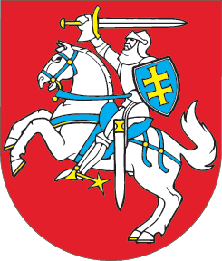

SEIMAS OF THE REPUBLIC OF LITHUANIA

RESOLUTION
ON THE SITUATION IN GEORGIA
20 November 2007
Vilnius

The Seimas of the Republic of Lithuania,
emphasizing the vital importance of democracy and the responsibility of the Georgian leadership for its development;
closely observing the events in Georgia and expressing concern over the latest events in the state, and supporting the aspirations of Georgia to strengthen statehood, develop democracy, market economy and integrate into the Euro-Atlantic area,
welcomes the fact that the compromise has been reached and the date of early presidential elections has been announced, and is convinced that this is the right step seeking to handle a political crisis in a peaceful and democratic manner;
condemns any attempts of other states to support separatist movements in the country, and notes that territorial integrity of Georgia is undisputable and unconditionally recognised and supported by the international democratic community;
welcomes the decision of the Georgian leadership to lift the state of emergency in the whole territory of the country;
urges the Georgian leadership and the opposition to continue a constructive dialogue as only peaceful democratic measures would help overcome the political crisis in the country;
invites the friendly Georgian nation to unite and reject any attempts to provoke further unrest, and the Georgian leadership – to respect the freedom of the mass media and ensure timely, free and fair elections.

SPEAKER OF THE SEIMAS VIKTORAS MUNTIANAS

