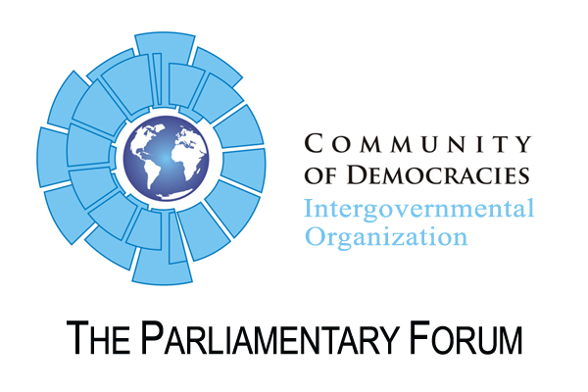
Resolution

Calling for improvement of the political and civil society situation in Belarus
CoD 10th Anniversary Meeting, 3 July 2010, Krakow

Whereas the dictatorial authoritarian regime is not an electoral democracy, serious and widespread irregularities have marred all recent elections. Amendments to the electoral law adopted in 2009 give the parties more opportunities to campaign but still do not provide for a transparent vote count. The April local elections were once again disappointing with only five opposition candidates filling available local positions. The campaign period was unfavorable to opposition members, many candidates withdrew from local elections because of continuous threats and harassment from government authorities. The presidential election will take place in Fall 2010 or Winter 2011, political parties are preparing to run opposition candidates offering economic reforms and issue-campaigns but it is certain they will face continued harassment and prosecution from the authorities.
Whereas President Aleksandr Lukashenko continues to curtail press freedom, libel is both a civil and criminal offense, and an August 2008 media law gives the state a monopoly over information about political, social, and economic affairs. The most recent Internet decree signed by President Lukashenko on February 1 contravenes standards set forth in the Eastern Partnership Agreement. The decree is effective as of July 1 and will require all internet providers to store data on each individual’s internet usage for a full year and provide that information to law enforcement agencies upon request. Internet service providers are also required to block access to any website within 24 hours of being asked to do so by government regulators.
The Parliamentary Forum of the Community of Democracies:
  - Calls for improvements in the conduct of elections in Belarus in time for the 2010-2011 presidential election;
  - Calls on the government of Belarus to seek further improvements to its election law in conjunction with the OSCE-ODIHR Office in Warsaw;
  - Encourages the authorities to register opposition candidates in accordance with election law procedures;
  - Encourages the authorities to allow political parties and civil society groups to hold public meetings and have access to media; and
  - Discourages the government from restricting internet freedoms which are now possible under a new Internet decree.

