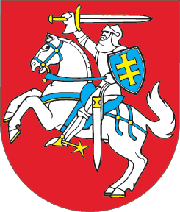
SEIMAS OF THE REPUBLIC OF LITHUANIA

RESOLUTION
ON THE REMEMBRANCE OF THE VICTIMS OF THE SREBRENICA GENOCIDE
20 May 2010
Vilnius

The Seimas of the Republic of Lithuania,
commemorating the massive killings of people, unprecedented after World War II, perpetrated in the town of Srebrenica (Bosnia and Herzegovina) on 11 July 1995, where the troops of the Republic of Serbia commanded by General Ratko Mladić killed more than 8 000 Muslim men and boys;
drawing attention to the fact that in 2004 the International Criminal Tribunal for the Former Yugoslavia and in 2007 the International Court of Justice declared the massacres at Srebrenica an act of genocide;
noting that the committed massive killings of armless people were carried out taking advantage of the impotence of the United Nations Protection Force stationed in and around Srebrenica and in violation of the principles of universal humanism;
emphasizing the importance of the European Parliament resolutions on Srebrenica adopted on 7 July 2005 and 15 January 2009 and the implementation thereof to historic justice;
being of the opinion that it is important to continue implementing the prospect of EU membership of all countries of the western Balkans and to ensure further cooperation with the International Criminal Tribunal for the Former Yugoslavia, with the view to eventually achieving reconciliation of the nations,
invites to honour appropriately the victims of the massive killings at Srebrenica and to commemorate the anniversary of victims of the Srebrenica genocide on 11 July;
highly estimates committed action of the International Criminal Tribunal for the Former Yugoslavia and calls for bringing all those responsible for the genocide at Srebrenica to justice;
expresses the conviction that the appropriate remembrance of the victims of the Srebrenica genocide will become a lesson, learnt by people across Europe, of a difficult past and the end of the former discord;
supports every international effort to further restore the mutual confidence among the nations of the former Yugoslavia, and
calls for a constructive dialogue ensuring the stability of the region of the western Balkans.

SPEAKER OF THE SEIMAS IRENA DEGUTIENĖ

