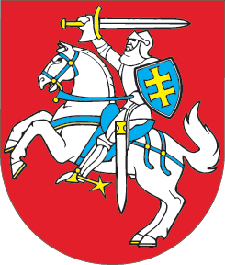

SEIMAS OF THE REPUBLIC OF LITHUANIA
RESOLUTION

ON RELATIONS BETWEEN THE RUSSIAN FEDERATION AND GEORGIA

17 October 2006
Vilnius

The Seimas of the Republic of Lithuania has received with concern the news about the decision made by the Russian Federation to suspend all rail, sea, air, road and postal links with Georgia since 3 October 2006. Considering the already imposed ban on the sale in the territory of the Russian Federation of wine and mineral water produced in Georgia, all this can be treated as means of economic pressure seeking to attain political goals.
The Seimas of the Republic of Lithuania regrets that the reaction of the Russian Federation against the lawful detention of its four officers in Georgia, later benevolently handed over to the Organisation for Security and Cooperation in Europe (OSCE), was inadequately strict and invites the Russian Federation to lift previously and currently imposed economic sanctions against Georgia.
The Seimas of the Republic of Lithuania calls on the Russian Federation and Georgia to resume a political dialogue adhering to the principles of international law including the recognition of sovereignty and territorial integrity of states, as it is the only way of achieving peace and stability in the South Caucasus.

SPEAKER OF THE SEIMAS VIKTORAS MUNTIANAS

