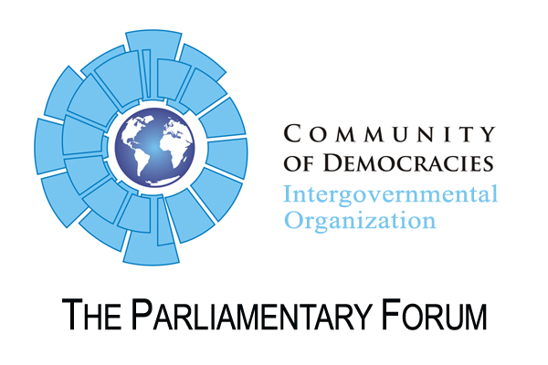
RESOLUTION

Calling for support of Cuba’s pro-democracy movement

CoD 10th Anniversary Meeting, 3 July 2010, Krakow

Whereas Cuba’s pro-democracy movement (hereinafter “the Movement”) has grown significantly in the last several years, and specific expressions of the movement are evident today in the explosion of bloggers on the island, independent journalists, musicians, artists, writers, and others, who are using their talents to denounce the repression of the dictatorship while putting forth new ideas for the transition to democracy;

Whereas there are still extraordinary obstacles to overcome, such as continued repression by the totalitarian dictatorship, extremely limited access to the internet and “texting” capabilities, a lack of a coherent message of solidarity from the international community, with very few actions by democratic governments to support the movement on the island;

Whereas the dictatorship has continued to use violence and deplorable prison conditions against its political prisoners such as the martyr Orlando Zapata Tamayo who responded to this appalling treatment by engaging in a hunger strike that lasted eighty three days before his death;

Whereas there are members of the Movement who are on hunger strikes, such as Guillermo Fariñas who is calling for the release of the most gravely ill political prisoners;

Whereas there are members of the Movement such as the “Ladies in White,” who are the wives, mothers, sisters, and daughters of political prisoners, that are continually harassed, intimidated, insulted, split upon, and often beaten by the Cuban regime’s state security agents for advocating for the release of the political prisoners;

Whereas the dictatorship continues to detain and harass members of the Movement to prevent these groups from assembling;

Whereas Cuban youth are often expelled from universities and/or prohibited from pursuing professions of their choice because of their political beliefs or those of their family members;
Whereas the dictatorship is fearful of the growth of the Movement;

Whereas the message of the Movement is coherent and clear in demanding freedom for all Cuban political prisoners, beginning with those who are gravely ill, freedom of expression, and free and fair, multi-party elections with international supervision;

Whereas this common position of the Movement, as reflected in the “Agreement for Democracy” signed by a wide range of Cuban opposition groups inside Cuba and in exile in 1998, and ratified in Lubin, Poland in 2007, requires greater recognition and solidarity on the part of the Community of Democracies;

Whereas now more than ever the Movement requires the solidarity of the international community; Now, therefore be it

The Parliamentary Forum of the community of democracies:

- condemns the brutality of the Cuban regime against Cuban political prisoners;

- honors the struggle of Cuban pro-democracy fighters such as the martyr Orlando Zapata Tamayo who died during a hunger strike;

- expresses its solidarity with the goals sought by the hunger striker Guillermo Fariñas;

- condemns the repeated attacks organized by the Cuban regime against the “Ladies in White”;

- condemns the arrests of dissident groups;

- expresses its full support for the Movement;

- calls on the Community of Democracies to make inquiries as to the precarious health conditions the ill political prisoners;

- calls on the Community of Democracies and its member governments to call attention to the deplorable conditions of prisons in Cuba and to pressure the Cuban regime to allow inspections of its prisons by the United Nations and other members of the international human rights community;

- calls for Cuban youth to have the right to freely pursue the education and/or profession of their choice without fear of reprisal or discrimination by the Cuban regime due to their political beliefs;

- calls for the immediate release of all Cuban political prisoners and for free multiparty elections with international supervision;

- calls on the Community of Democracies to take concrete steps to demonstrate its solidarity with the Movement by providing humanitarian and technological assistance to the Movement, urging foreign diplomatic posts in Havana to strengthen contacts with pro-democracy activists on the island, encouraging foreign dignitaries to visit Cuba for the sole purpose of meeting with pro-democracy activists, and looking for opportunities to support the common position of the Movement in the international community.

