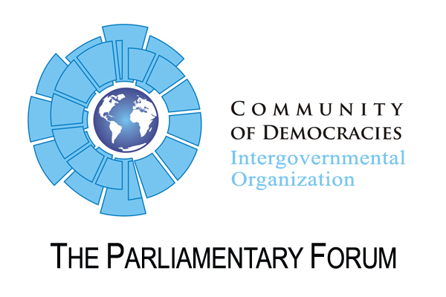

Resolution

Calling for improvement of the political situation in Ukraine
CoD 10th Anniversary Meeting, 3 July 2010, Krakow

Whereas after holding free and fair presidential elections in January 2010, democratic progress Ukraine achieved since 2004 embarked on the reverse trend,
Whereas the declared intentions of the government to realize structural and robust reforms have not yet provided tangible results,
The Parliamentary Forum of the Community of Democracies:
  - Encourages Ukraine’s authorities to uphold democratic principles and the rule of law with the special attention to the freedom of speech and peaceful assembly in Ukraine;
  - Discourages the majority coalition and the government from introducing the legislation aimed to undermine independence of the judicial branch of power;
  - Calls for ensuring free and fair local elections to be held on 31 October 2010;
  - Urges Ukrainian government to send the draft law on the local elections for an expertize to the Venice Commission of the Council of Europe before proposing it for the final adoption at verkhovna Rada;
  - Expresses its concern regarding the political harassment against representatives of the opposition;
  - Encourages Ukrainian government to realize economic reforms aimed at raising prosperity, energy efficiecy and eliminating corruption;
  - Encourages Ukrainian government to facilitate favourable conditions for strong and vibrant civil society;
  - Discourages Ukrainian government from statements that incite the ethnical intolerance and divide the society in Ukraine;
  - Encourages Ukrainian authorities for improvement with gender issues in Ukraine;
  - Discourages the authorities from interfering activity of Ukrainian and international NGOs in the territory of Ukraine and from restricting the international experts from freedom to express their opinion on the political and economic situation in Ukraine;
  - Encourages Ukrainian government to continue existing regional initiative aimed at fostering international cooperation and promoting democracy in the regions of East-Central Europe and Eurasia;
  - Encourages the CoD governments to constantly monitor the status of democracy processes in Ukraine.

