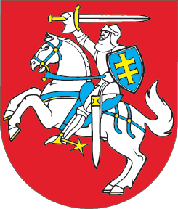

SEIMAS OF THE REPUBLIC OF LITHUANIA

STATEMENT
ON THREAT TO THE INDEPENDENCE AND
TERRITORIAL INTEGRITY OF GEORGIA
13 May 2008
Vilnius
The Seimas of the Republic of Lithuania,
being concerned about the actions of the Russian Federation escalating tension between Georgia and the Russian Federation;
reminding the Russian Federation of its international commitments to respect the territorial integrity of Georgia and to develop relations based on mutual respect as specified in Resolution 1808 adopted by the Security Council of the United Nations Organisation as well as in the bilateral agreements between Georgia and the Russian Federation which are in line with the Partnership and Cooperation Agreement between the European Union and the Russian Federation;
expressing concern about the statements by the heads of the Russian Federation and the State Duma regarding the establishment of official relations of the Russian Federation with Georgia’s separatist regions of Abkhazia and South Ossetia, as well as about the policy of the Russian Federation which is being carried out in this region;
stressing that the unilateral decision of the Russian Federation to send additional military units to Georgia’s separatist region of Abkhazia, increasing military tension contradicts the aspirations declared by the Russian Federation to act as a neutral mediator and the international commitments of Russia,
states that negotiations between the European Union and the Russian Federation on a new cooperation agreement must include an issue concerning constructive participation of the Russian Federation in resolution of the “frozen conflicts;
supports the efforts of the authorities of Georgia to seek peaceful means of conflict settlement and welcomes a new peace initiative to resolve the conflict in Abkhazia;
calls on the governments of the Member States of the European Union and NATO, and the international community, taking into consideration the objectives declared by the European Union to contribute to conflict resolution in the South Caucasus and the commitments of NATO to promote stability, progress and cooperation in the region, to be more active with a view to preserving the territorial integrity of Georgia;
urges the heads of the Russian Federation and the State Duma to refrain from actions that may violate the sovereignty of Georgia, pose a threat to the territorial integrity of this state, security and stability of the region;
calls on the Russian Federation and Georgia to resume political dialogue within the shortest possible time in seeking peace and stability in the South Caucasus;
supports the efforts of the authorities of the Republic of Lithuania to stabilise the situation in the South Caucasus.

speaker of the Seimas Česlovas Juršėnas

