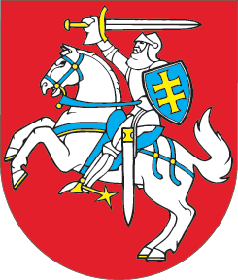

SEIMAS OF THE REPUBLIC OF LITHUANIA

RESOLUTION
ON THE PAYMENT OF DAMAGE CAUSED BY
THE USSR OCCUPATION

16 January 2007
Vilnius

The Seimas of the Republic of Lithuania,
recalling the act of aggression carried out on 11-13 January 1991 by the USSR armed forces against the independent state of Lithuania and its people;
paying honour to the defenders of Lithuania’s freedom who were killed or injured on 11-13 January 1991, and to their relatives;
appreciating the support of democratic Russia for the State of Lithuania during the aggression of 11-13 January 1991,
emphasises the importance of giving meaning to the events of January 1991 and the restoration of justice for the Lithuanian nation;
expresses its hope that the Russian Federation, which by signing the 29 July 1991 Treaty between the Republic of Lithuania and the Russian Soviet Federative Socialist Republic on the Foundations of Interstate Relations recognised the independent Republic of Lithuania restored on 11 March 1990, will assess the liability of the persons who directed and participated in the aggression against the State of Lithuania on 11-13 January 1991 and will help the law-enforcement institutions of the Republic of Lithuania to seek justice;
urges the Russian Federation, as the successor to the rights and obligations of the USSR, to launch consultations with the Government of the Republic of Lithuania regarding the payment of damage caused by the USSR occupation.

SPeaker of the seimas Viktoras Muntianas

