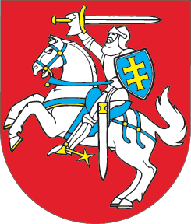

SEIMAS OF THE REPUBLIC OF LITHUANIA

RESOLUTION
On compensation to the victims of the USSR aggression perpetrated during and after 11-13 January 1991 and to their families
19 January 2010
Vilnius

The Seimas of the Republic of Lithuania,
reminding that the USSR armed forces carried out the act of aggression against the independent State of Lithuania and its people on 11-13 January 1991;
stating that many unarmed defenders of Lithuania’s independence were killed and seriously injured as a result of these USSR government and military actions;
emphasising that when the independence of the Republic of Lithuania, as established by the acts of 11 March 1990, was recognised by Russia in the Treaty of 29 July 1991 between the Russian Soviet Federative Socialist Republic and the Republic of Lithuania on the Fundamentals of Interstate Relations, the attacks by the USSR on 11-13 January 1991 are regarded by both the countries as aggression against the sovereign State of Lithuania;
taking into consideration the fact that the Russian Federation is recognised as the successor state to the USSR by the world’s countries and the Russian Federation itself,
proposes that the Government of the Republic of Lithuania should:
1) officially apply to the Government of the Russian Federation concerning compensation payments to the victims of the USSR aggression perpetrated during and after 11-13 January 1991 and to their families;
2) propose to the Government of the Russian Federation to address the issue of compensation humanely so as to settle it by 13 January 2011, the 20th anniversary of the Freedom Defenders’ Day.

SPEAKER OF THE SEIMAS IRENA DEGUTIENĖ

