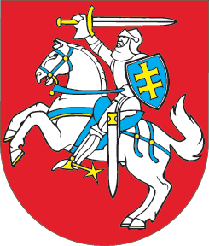

SEIMAS OF THE REPUBLIC OF LITHUANIA

RESOLUTION
ON MEMBERSHIP OF THE REPUBLIC OF ICELAND
IN THE EUROPEAN UNION
23 July 2009
Vilnius

The Seimas of the Republic of Lithuania,
welcoming and supporting the decision of the Parliament of the Republic of Iceland of 16 July 2009 to empower the Government of the Republic of Iceland to apply for membership of the European Union, and the decision of the Government of the Republic of Iceland to submit an application of the Republic of Iceland for membership of the European Union to the Kingdom of Sweden holding the Presidency of the Council of the European Union;
remembering and highly appreciating the support offered by the Republic of Iceland to the Lithuanian nation and the State of Lithuania when the Republic of Iceland was the first to recognise the re-established independence of Lithuania,
invites the parliaments and governments of all Member States of the European Union and the European Parliament to support the aspiration of the Republic of Iceland to accede to the European Union by requesting the European Commission to submit, by the end of 2009, its opinion on preparation of the Republic of Iceland to open EU accession negotiations;
hopes that the Republic of Iceland will be ready to open the negotiations as early as the beginning of 2010;
declares determination of the Republic of Lithuania to share its experience of the EU accession negotiations.

SPEAKER OF THE SEIMAS Arūnas Valinskas

